IST 363

Lab 03

This Lab Covers
- Reset Stylesheet
- SASS Preprocessing, Variables, Partials and Importing, Nesting, Mixins and Extend

Lab Corrections
- If you didn’t get a perfect score on the animated page (name animation) in lab 2, make corrections and turn in your url for this part. You don’t need to correct the other animations.

warmup

  - Why would a developer choose SASS over plain CSS?
  - Using the syr.edu home page, give an example where syr.edu could use a SASS variable. Give me the SASS code and a brief statement of how a variable would be helpful.
  - Using the syr.edu home page, find an example of where you could use nesting to replace a descendant selector (you may have to view the source code for this). Give me the SASS code and a brief statement of how a variable would be helpful.
  - Using the syr.edu home page, find an example of where you could use a mixin. Give me the SASS code and a brief statement of how a variable would be helpful.
  - Using the syr.edu home page, find an example of where you could use an extend. Give me the SASS code and a brief statement of how a variable would be helpful.

SASS Page

  - SASS File Structure
SASS projects have a common file structure adopted as a best practice by web developers. There’s an example below but the idea is you keep all the snippets of SASS in a partials folder, the webpage and stylesheet can go in the main folder and of course as usual, have an images folder. Below is an example of a well-organized SASS folder structure. For this part, set up your files in this way.
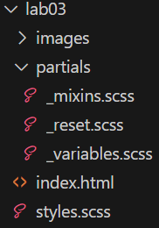
  - SASS Page
You will be creating a food Blog. I’ve pasted the desktop and mobile view images below. The scales are different on my screenshots, but when you code this, you will see that the images are larger at mobile size. You don’t have to make this look good at tablet size unless you want to. There’s a .zip file of the processed images up in Blackboard. Here are my colors:
lime - #e4fdc3
mint - #8ae2c8
orange - #e89b6a
melon - #e2625c
  - Nav Animation
Add a transition to the nav to show when an item is moused over.
  - What I’m expecting from your SASS coding:
    - a reset stylesheet included using SASS
    - at least one example of SASS nesting
    - reused styles with a variables.scss include – for example colors or fonts
    - reused CSS blocks of properties with mixin or extend – for example all the boxes for the recipes
You must use at least one mixin and one extend to get full points.
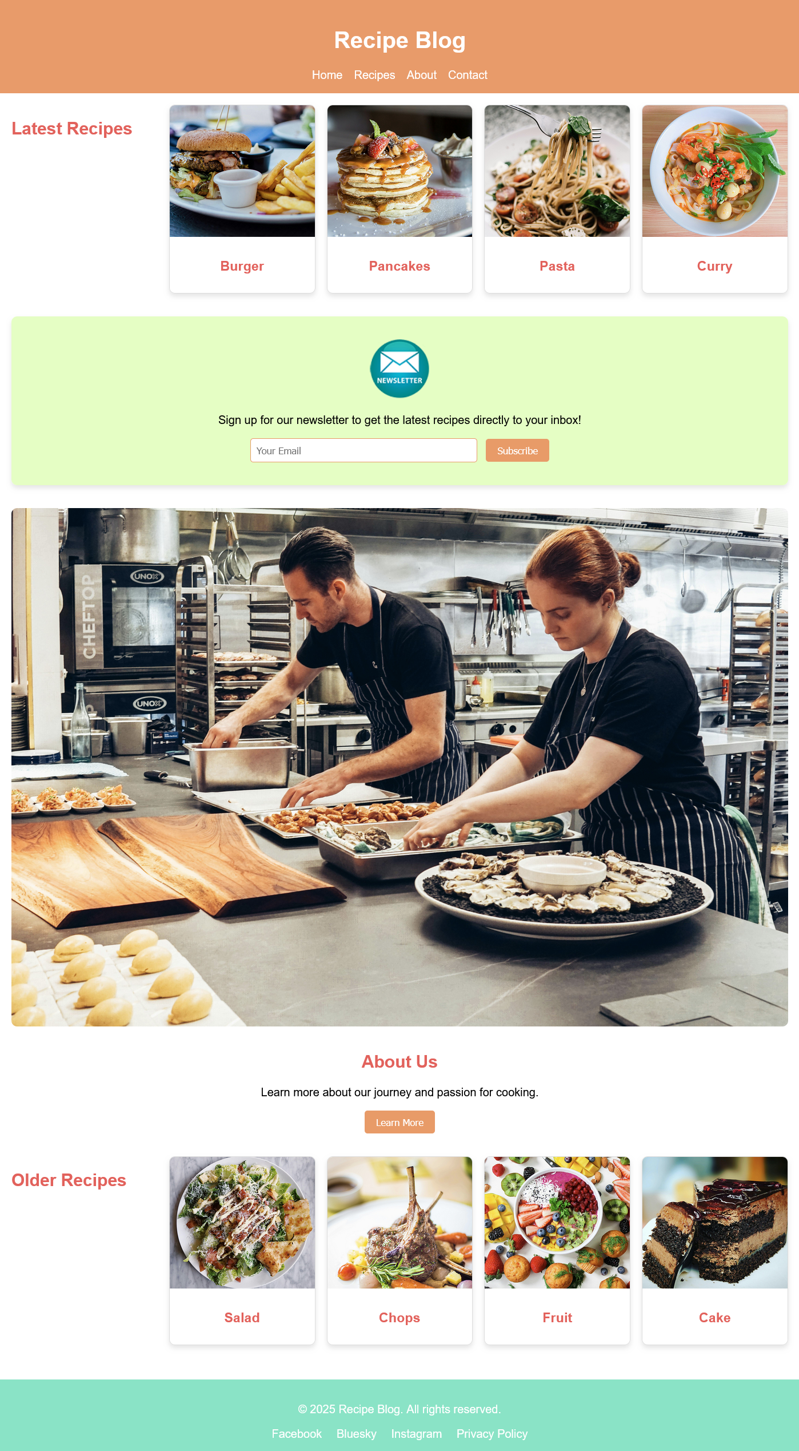

What to hand in
Note that if any URL doesn’t work for me, you will get a zero on this part. Ensure github.io is part of the URL in the address bar. If it’s not, you haven’t given me the correct link.
- For the corrections hand in the URL of the corrected page.
- For the review questions, paste your answers into the template provided in Blackboard.
- For the SASS page, hand in the URL
Use the answer template!

